SharePoint Navigation

SharePoint Online (Office 365) https://centralremedialclinic.sharepoint.com/SitePages/Home.aspx
This will be set as the home page in Microsoft Edge (Recommended browser for SharePoint).
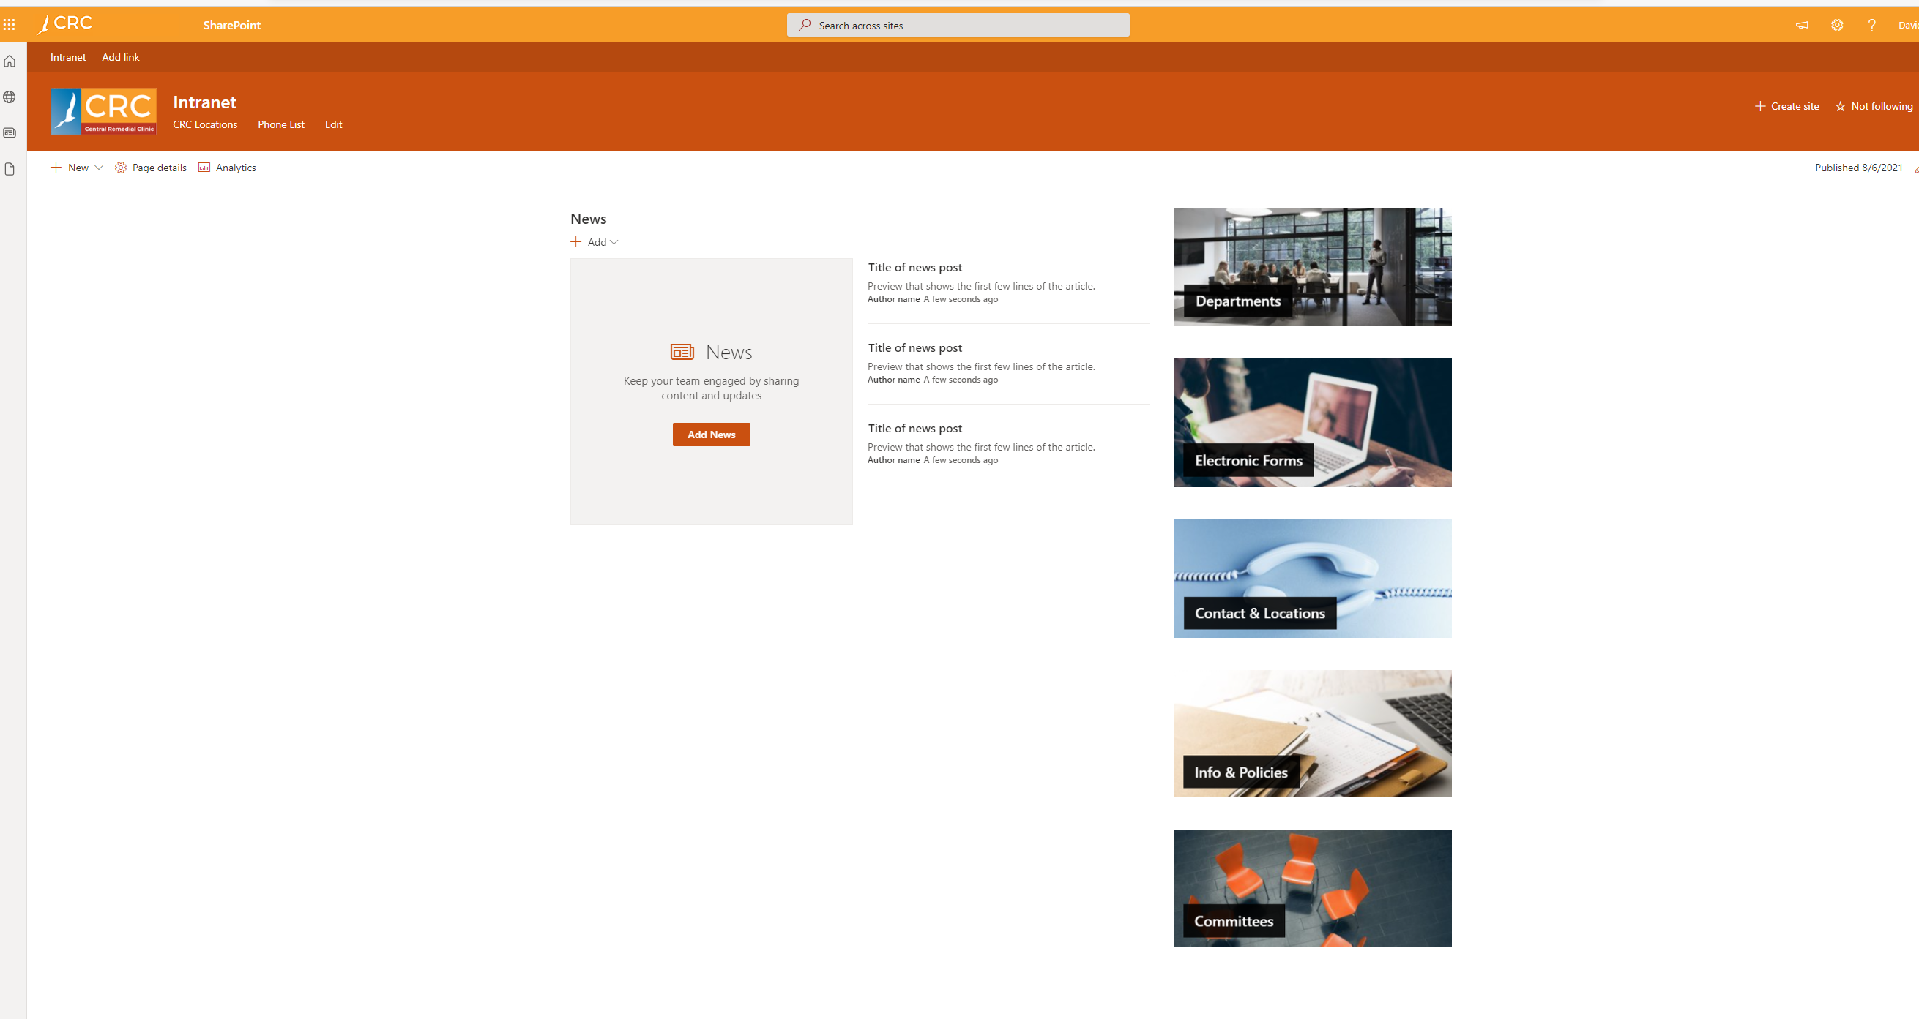

Home Screen
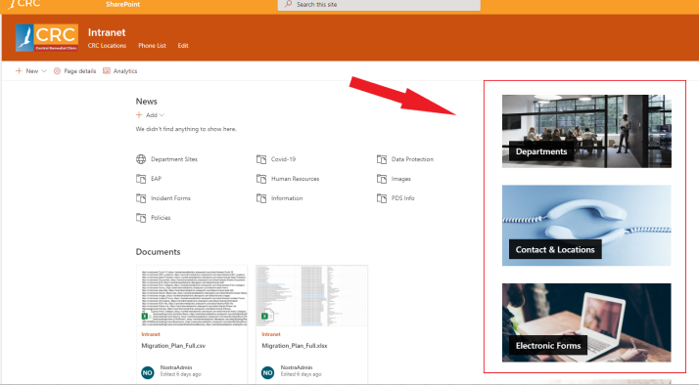

There will be 6 main tiles along the right-hand side of the home page

- Departments
- Contact & Locations
  - Phone List and Office Locations
- Electronic Forms
  - IT – New User Request, mobile request ,Leaver Form, Maintenance request. etc
- Info & Policies
  - Covid-19, Data Protection, Forms, Incident Forms, Human Resources, Information, PDS Info, Policies
- Committees
- Room Bookings

Departments Tile
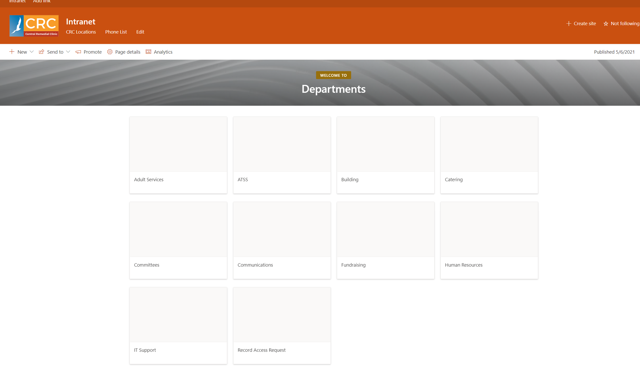

Info and Policies Tile
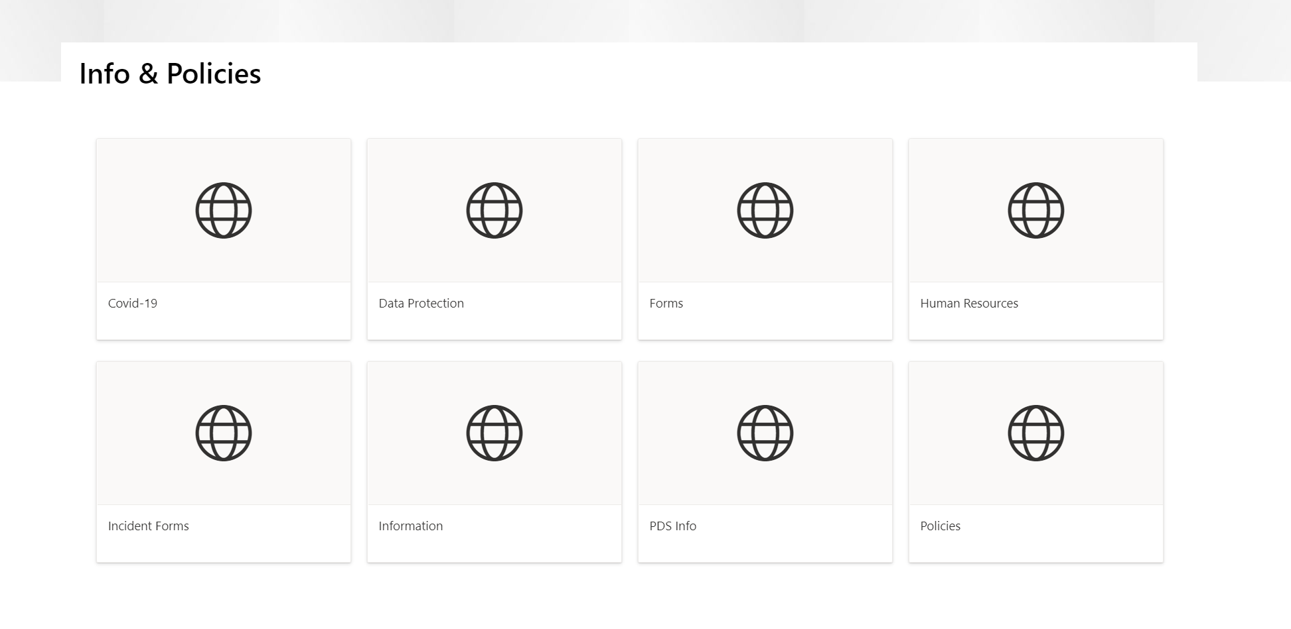
Room Bookings

Room Bookings can be made from clicking on the room bookings tile on the home page.
This will bring you into a site with tiles for each room that can be booked.
Click on the room that you want to book and then add an entry to the room calendar.

