CRC Internal Phone Directory

The CRC Internal Phone Directory is available on SharePoint under the Contact & Locations tile on the Home page. The App can also be added to MS Teams.

Click on the Phone Directory App tile to open the App
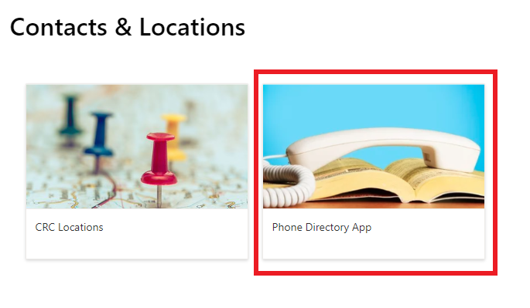
Initial login requires the following steps
Click Sign In
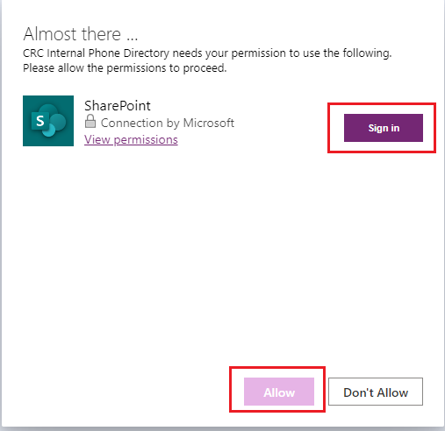
Click Create
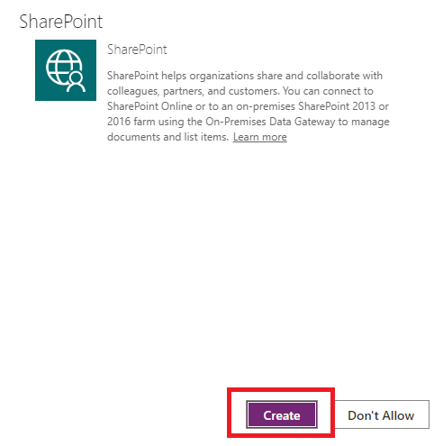

Click Allow

You can search by Surname, Firstname or number.
There is also an option to filter by dept or Site.

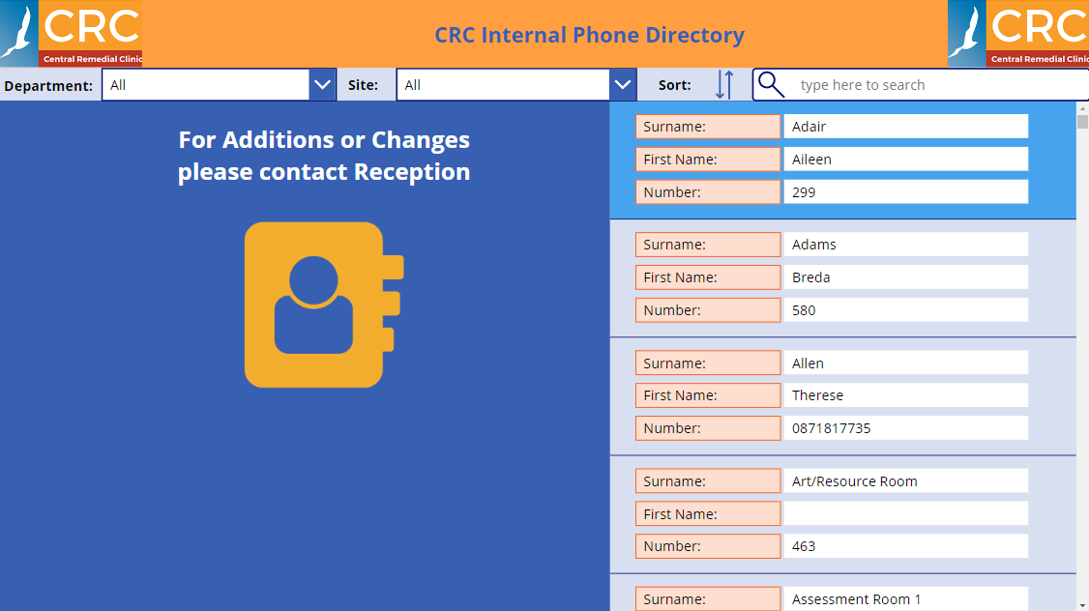

Adding the App to MS Teams

Once Teams is opened, click on the ‘Apps’ button located at the bottom of the App bar

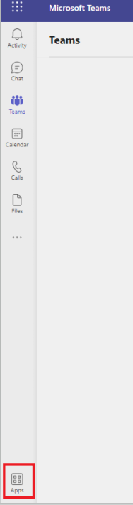

Select ‘Built with Power Platform’

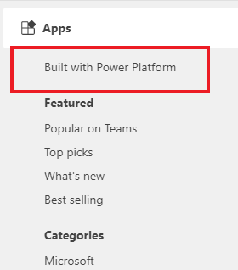

This will display all apps that you have acces to. Select the App that you would like to add to teams and then choose the Add button.** Do not click on the dropdown arrow as this will add to a specific Team/Channel.

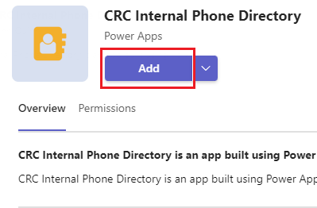

Your selected App is now available on the App bar

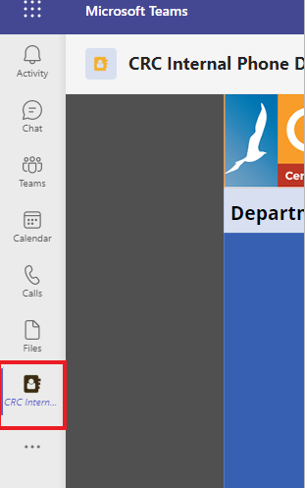

You can open the App in the current Teams window or right click and ‘Pop out app’ to open in a new window.

