Configure VPN site

Click on ‘System Tray’ arrow in Taskbar – bottom right hand corner of screen.
Right click the ‘lock’ symbol
Click ‘VPN Options’

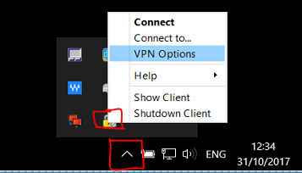

Click New
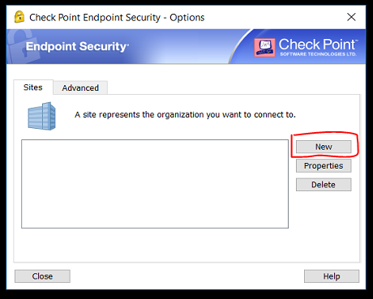

Click Next..

Enter Server Address - 137.191.236.178
Tick Display name and enter ‘friendly name’, if required.
Click Next

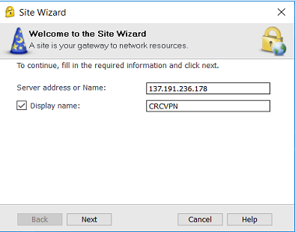

Select ‘Trust and continue’

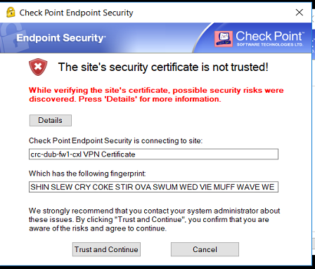

Check ‘Username and Password’ is selected and click Next

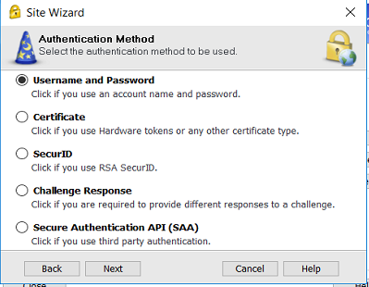

Finish.

To Access VPN

Click System Tray arrow in taskbar
Right click ‘lock symbol’
Click ‘Connect’

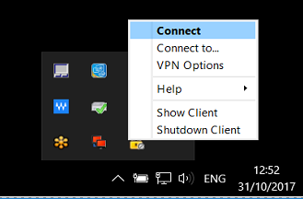

Enter your usual network credentials to log in – No @crc.ie

