Fixing the VPN issue: “Site not responding”

Step 1 – locate the Padlock tray icon in the bottom right hand side of your screen (near the time)
Step 2 – Right click on the padlock icon and select “Disconnect” (if it says “connect” Skip this step)
Confirming yes:

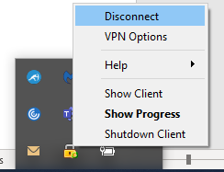
Step 3 – Once disconnected right click the Padlock icon again and this time select “VPN Options”:
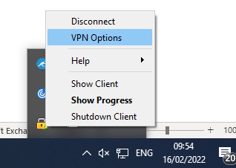

Step 4 – Click the delete button on the right, then confirming yes:
If you do not have an entry here proceed to step 5
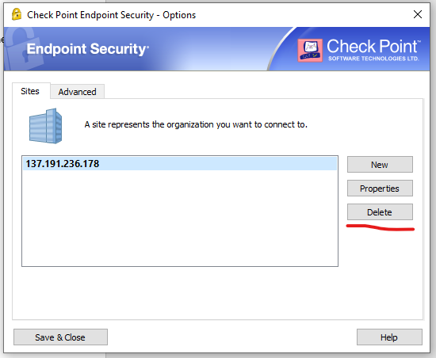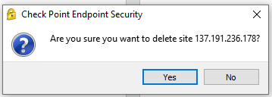

Step 5 – Now click the new button:
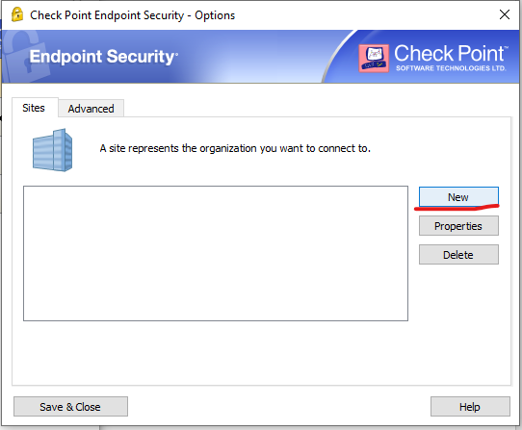
This will bring up the Site Wizard:
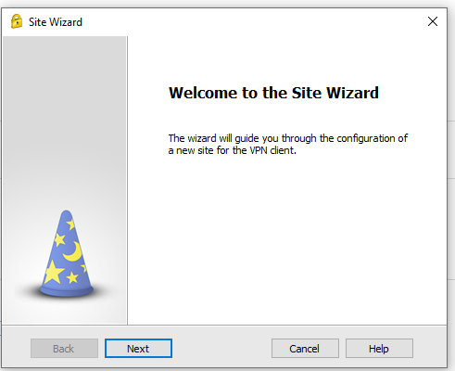
Step 6 – Click next and wait for the progress bar to fill, once it finishes it will bring you to this page:
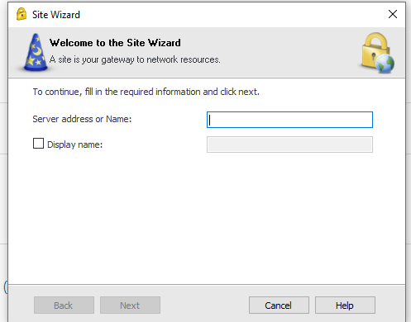
Step 7 – in the box for “Server address or Name” please enter in these digits including the full stops:

Then select next.
Step 8 – Leave everything default and continue on the wizard by clicking next:
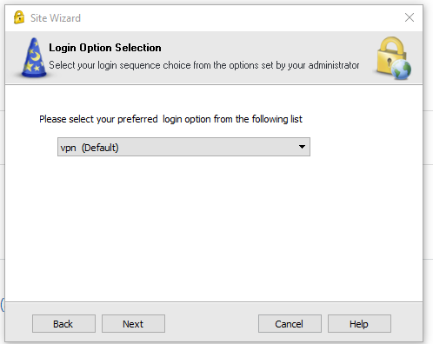

Step 9 – Press next again not changing anything:

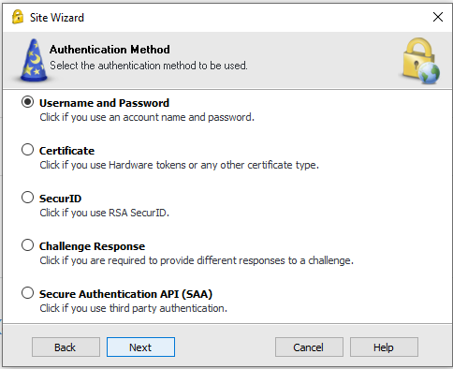

Step 10 – you will then see this page:
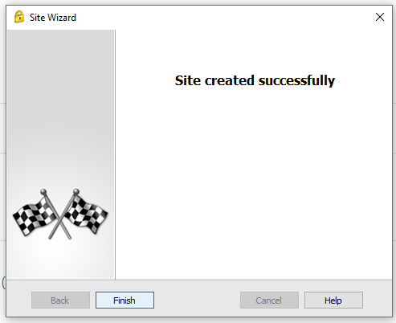
Click Finish.
Step 11 – a box will appear asking if you would like to connect, click yes:
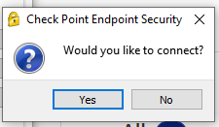
Step 12 – this will bring us back to the familiar log in page of the VPN:
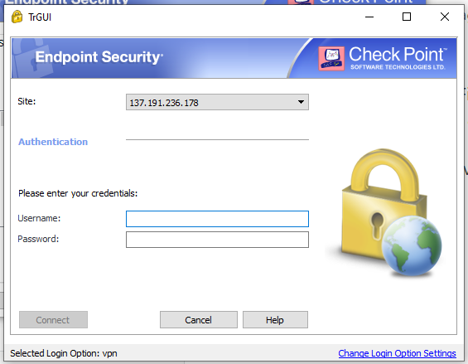
Go ahead and enter your username and password as normal, click Connect.
After a few moments it will inform you that the VPN has connected.
You can now access all of your CRC resources once more.

