Steps required to set up the Microsoft Authenticator app on a phone

Notes before you try to set up the Authenticator app:
- The option to receive a prompt via text message has been turned off for security reasons.
- You cannot “sign into the app” you must enrol via the “Scan QR option” only !!!!!!!
- If you do not see the message “more information required” at step 2 you need to call IT to remove your old details from the system.
- A new phone requires this whole process to be repeated and IT must be informed or else your old device will be still in the system and nothing you do will activate the new one!!!
- Uninstalling the app and reinstalling requires this process to be repeated entirely.
- The completed setup of this app will not transfer anywhere regardless of using the same sim card, phone or email account, the app will always need to be re enrolled if any changes in your setup occur
- Any security codes asked for in this process of this setup are referring to your phones unlock code/pattern/fingerprint or facial scan

Step 1 – If you have a new phone or uninstalled the app inform IT to remove your old setup then follow these steps, This will not work until after you have informed IT to remove your old phone
- Log into 365 via an internet browser on a separate device (not your phone) ie: Laptop/Desktop
- go to address: https://portal.office.com
- Press the sign in button
- Log in here with your email and password:

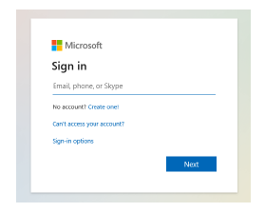

Step 2 –
- This box will appear informing you that more information is needed:
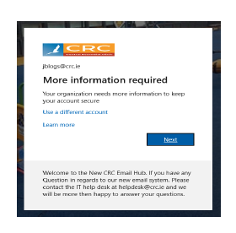
If this box does not appear then you must call IT 344 to have your old details removed from the system!
- Press next
- The Wizard will go on to tell you that you need to download the Microsoft Authenticator app from whatever app store your phone uses – “Google Play store for Android” & Apple App Store for iPhones:
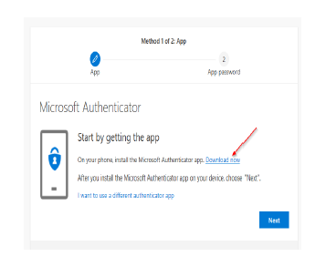
If you already have the app installed you can skip this step!
- Click next
- Continue to click next until it shows you a QR Code (Barcode):

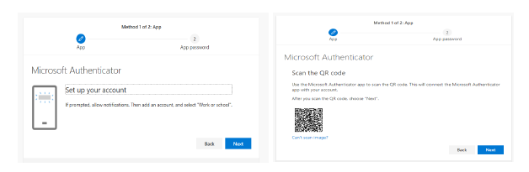

- Leave this Barcode up on your screen.

Step 3 –
- Now we must use your phone for the next part
- Open the Microsoft Authenticator app on your phone
- Select if prompted to “Add new account” or if you already had an account before but its not working – then locate the 3 dots which then will show you an option to “add new account”
- When prompted for type of account choose “Work or School account”
- When prompted with the options “Scan QR Code” or “Sign in” please choose “Scan QR Code”
- The app will possibly ask your phone for permissions to use its camera, you must grant this access either “this time only”, “Only while using this app” or “All the time” it does not matter as long as you allow it with one of those answers
- The camera of your phone should now open automatically

Step 4 -
- Point the camera at the QR code still displayed on your Computer
- After a split second your phone will change from the camera to a screen that shows your email address and the word CRC
- When you see your account on the phone like this you can now press next on the computer where the barcode is displayed
- The next window informs you “Lets try it out” this step is crucial to finishing off the setup:

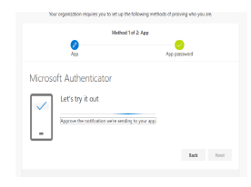

- Click next and look at your phone
- A prompt will have come to your phone asking you “Approve or Deny”
- Choose Approve, the browser window on the computer will now change to show that the prompt was indeed approved:

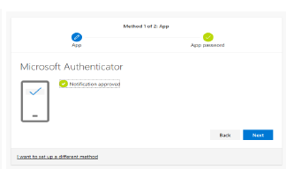

- Select next
- This window should now appear:
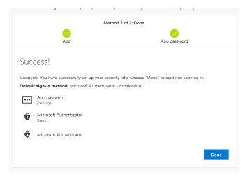

- Click done to finish the process

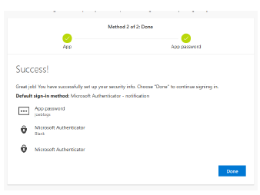

Your phone is now completely set up to use the Microsoft Authenticator App and will simply send a notification to your phone from now on asking “Approve or Deny” congratulations you are done.

Please note that If your phone at any stage of the setup prompts that “Push notifications must be allowed” this setting is specific to your phone and we cannot assist in locating where to turn it on as every phone is different.
This will need to be enabled or allowed for the correct functioning of this app.
This setting is usually found under the app permissions in your phone.
The app may take you directly to this setting or it may expect you to go and find it yourself.
We are only able to assist in finding this setting if you bring your phone physically to us in the IT department.

