# New starter procedure

## Logging into your computer for the first time:

* Firstly, power on your machine.
* Upon starting your machine, you will first need to log in:

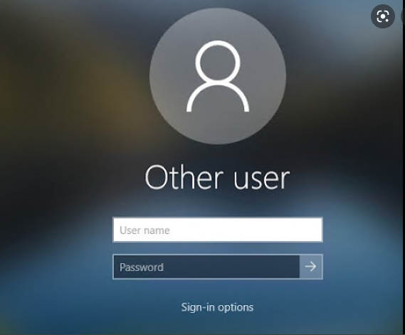

* Enter your username/password.
* The naming convention for login’s are first letter then surname for example:

Name: Joe Bloggs Username: jbloggs Usernames are not case sensitive!

* If this is your first-time logging in - your password will prompt for you to change it after you enter the temporary password that was provided to you upon starting, enter your temporary password to begin:

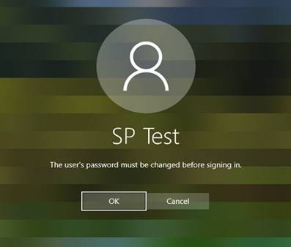 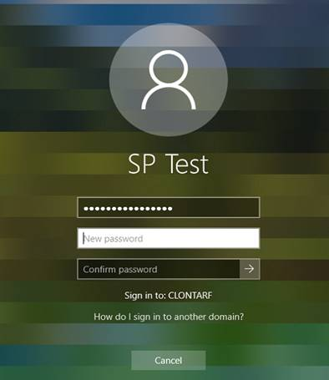

* Click OK and then enter your new personalised Password.
* Hit enter, you will receive a message telling you that the password has successfully changed.

## Welcome to your new Desktop

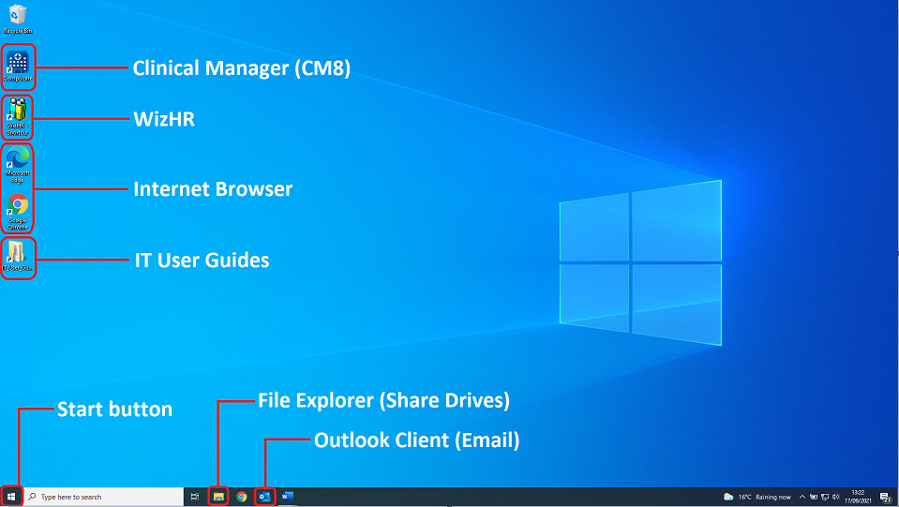

Your new desktop will now open and will already contain some of the most frequently used tools

However, depending on which department you work for there may still be further to set up, if this is the case please submit a ticket via email to [helpdesk@crc.ie](mailto:helpdesk@crc.ie) to have anything extra installed.

* Outlook may either be on your desktop or can be found by clicking the **Start button** and searching for the word “Outlook”.
* Open File explorer to access your Shared Drives - H:/ is for department specific folders and the P:/ drive is for your personal storage.

Now that you are settled in, you may be unsure of how to use some of these new systems, apps or devices - for this we have created the **IT User Guide’s folder** on your desktop, you can refer to this folder for in depth guides on many of the tools you will use day to day, these include:

|  |  |
| --- | --- |
| * Outlook / Email | * Desk phones |
| * 2 Factor Authentication | * CM8 |
| * VPN Checkpoint/working from home | * NIMIS |
| * The Intranet | * USB’s |
| * Zoom | * Microsoft Office |
|  |  |